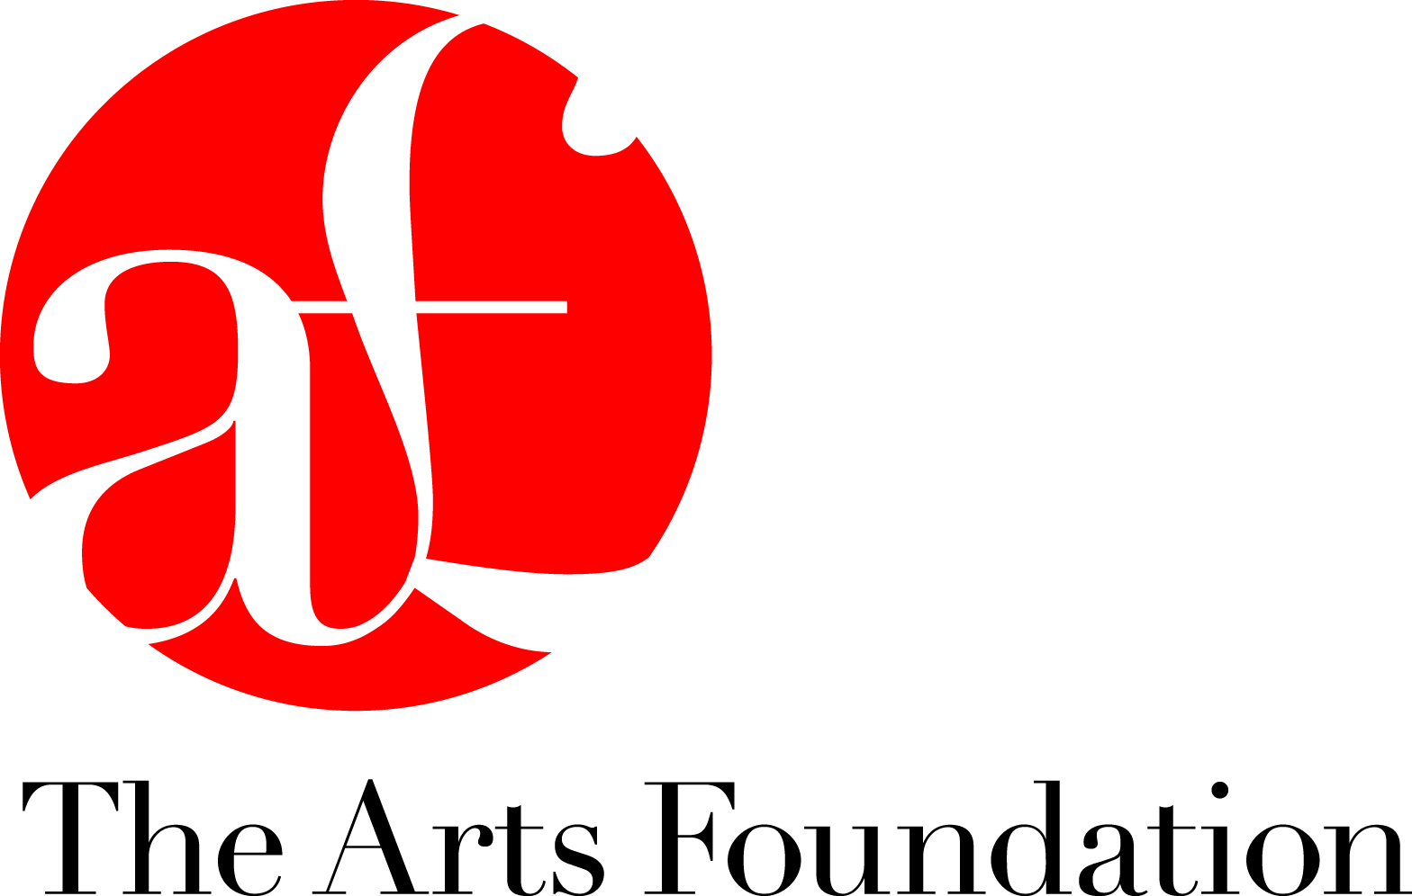

Press Release: For Immediate Release

The Arts Foundation Awards 2017
Filmmaker Sam Stevens Wins £10,000 Essay Filmmaking Fellowship

Filmmaker Sam Stevens has won the £10,000 Essay Filmmaking Fellowship in the annual Arts Foundation Awards 2017 with Charlie Lyne, Marianna Simnett and Sarah Wood each receiving runners up awards of £1000. The winners were announced at an award ceremony at Conway Hall, London last night (January 25), presented by guest of honour Will Self.

Sam Stevens said of his plans for the Fellowship, “In the wake of Brexit I feel a real need to look at British identity. I would like to produce a film and a book that will shine a light on a movement in the 1930s that was at the forefront of essay filmmaking practice in the UK.”

Chosen from a longlist of nominated makers, the award was judged by British artist, writer and award-winning filmmaker Andrew Kotting, writer and critic Maria Fusco and Mark Kidel, documentary filmmaker and writer specialising in arts and music.

Judge Andrew Kotting said of the winner, “A fine and inspired shortlist of both established and emerging talent made the job of choosing a winner very difficult, however in Samuel Stevens’ work we found diversity and rigour and a spirit that probed and cajoled. The pacing was immaculate and the rhythms of sound-image correlation were seductive and informative. The ambition of Samuel’s proposed essay film was also impressive and exact.”

Sam Stevens’ recently completed film Spanish Labyrinth (2016) traces the journey of avant-garde filmmaker Eli Lotar across Spain in 1931, echoing the main interests in his filmmaking, centering on ecological, social and political realities in Europe. His film Atlantopa (2009), for which he received mentoring from Adam Curtis, imagined a bridge across the straits of Gibraltar, a symbol of inter-continental unity, which would allow migrants to easily cross into Europe. The film won a Jury Award at the Ann Arbor Film Festival in Michigan (2010). Stevens has carved an international exhibition trail, participating in shows such as Una Idea de Europa at CENTROCENTRO, Madrid (2016) and New Semantics at the Whitechapel, London (2006).

Constantly looking to current issues as the primary source for his work, Stevens contributed several works to COBRA-RES’, a curatorial group who create art in response to actual events that trigger emergency governmental meetings. These ‘quick-reaction’ pieces bear witness to the influence of Dziga Vertov’s images of ‘life caught unawares’ in his own work, which he describes as “an observational method that attempts to frame the natural rhythms and performances of life”.

Spanish Labryrinth will be screened at film festivals from February 2017. www.vimeo.com/samuelstevens/spanishlabyrinthtrailer
www.samuelstevens.co.uk

The Arts Foundation announced six awards in total totalling £78,000 to emerging artists in Creative Non-Fiction, Essay Films, Furniture Design, Jazz Composition, Live Art and Materials Innovation.

For further information and images please contact: Pandora George, Bullet PR. 01273 775520 pandora@bulletpr.co.uk

About the Arts Foundation
Since the inception of its Fellowship Scheme, over £1,700,000 has been awarded by The Arts Foundation, supporting numerous artists from the fields of Performing and Visual Arts, Crafts, Literature, New Media, Film and Design. Previous winners have included film director Carol Morley (2003) and BAFTA award-winning director Asif Kapadia (2001), writers Ali Smith and Michel Faber and Artistic Director of the National Theatre Rufus Norris (Theatre Directing 2002). Trustees of The Arts Foundation include Director of Somerset House Jonathan Reekie, Choreographer Siobhan Davies and director Sir Richard Eyre.
www.artsfoundation.co.uk

